liquid leak dectection system specification
- Overview
Installation of a liquid leak detection system is recommended for continuous protection from the risk of water and other liquids leaking within critical areas of the building.
This complete liquid leak detection system shall be based on a digital monitoring unit, addressable sense cables, jumper cables and all required auxiliary equipment. This system shall detect and locate multiple leaks simultaneously as well as cable break faults.
We recommend the FG-NET digital unit from TTK.

- System performance
  - General
The liquid leak detection system shall identify any abnormal presence of liquid on any point of its connected sense cables, to the nearest metre.
In the event of a leak, an audible alarm is triggered and the dry contact is activated. The panel’s touch screen display shows the time and date of the alarm, the type of fault and the location of the leak to the nearest metre. Dynamic zone maps highlighting faults on the panel’s screen are available as an optional feature. A power failure relay shall be activated when the power shuts down.
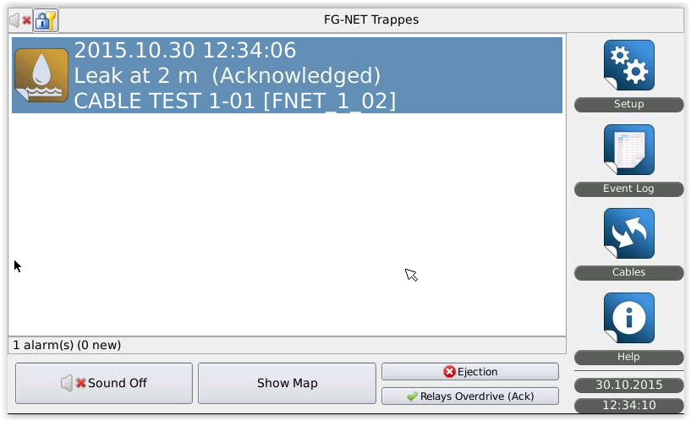
Figure 2.1.2 Example of the alarm message on the panel screen in case of leak
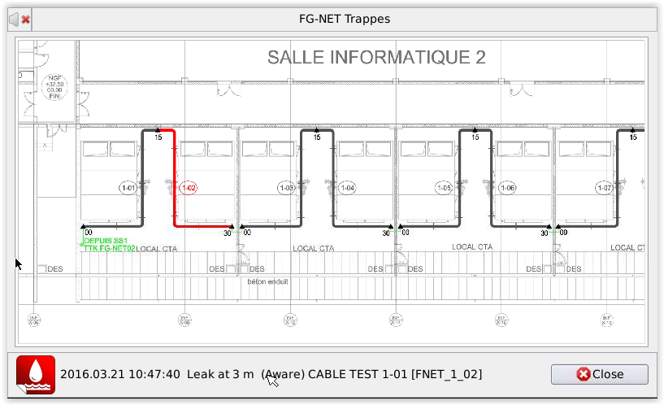
Figure 2.1.3 Example of the integrated map high lighting the default in case of leak
  - Sense cable length
The system shall be capable of monitoring up to 1800 metres of cable from a single monitoring unit. This length shall not include the jumper cable.
The panel shall be able to show all the cables connected and group them by zone.
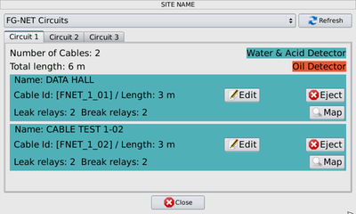
Figure 2.2 Example of the interface to view all cables connected on the panel
  - Multiple leaks
Every sense cable shall be able to detect and locate leaks independently. The system shall be able to show 120 simultaneous faults.
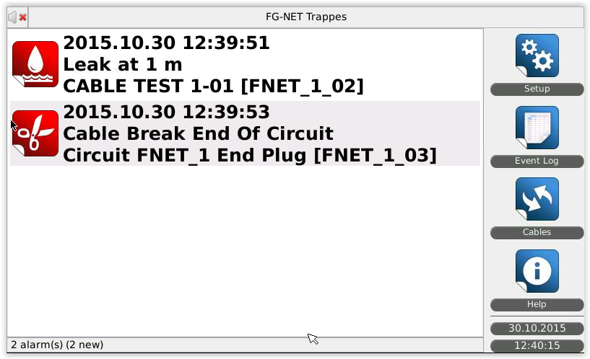
Figure 2.3 Example of the interface to view 2 faults on the panel
  - Cable break fault
Besides leaks, the system shall be capable of detecting any damaged sense cables (cable break). In the event of a cable break, an audible alarm is triggered and the dry contact is activated. The dynamic zone maps showing a cable break and highlighting the exact location on the panel’s screen are available as an optional feature.
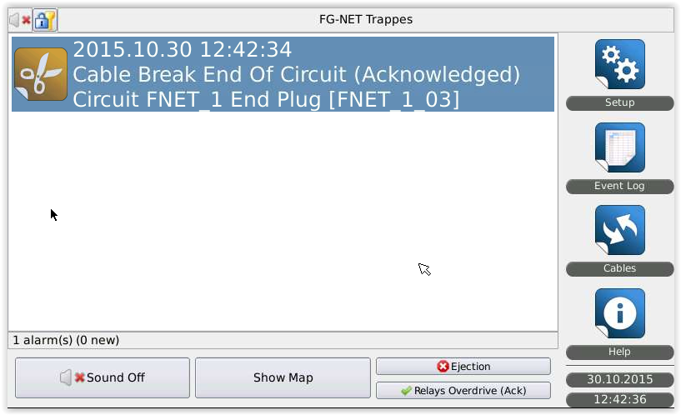
Figure 2.4.1 Example of the alarm message on the panel screen in case of cable break.

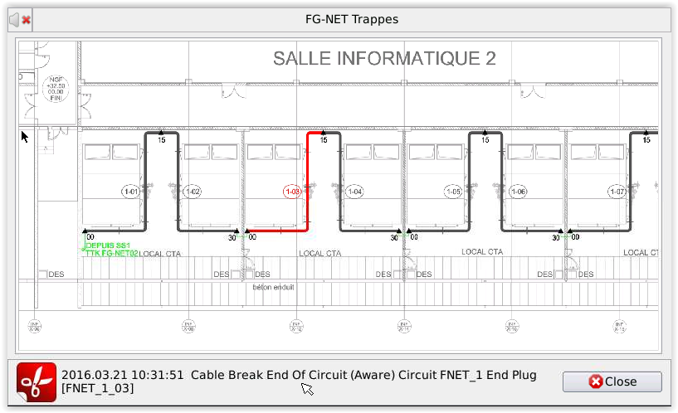
Figure 2.4.2 Example of the integrated map high lighting the default in case of cablebreak
  - Liquid types
The system shall be capable of detecting conductive liquids such as water, bases and acid, or non-conductive liquids as hydrocarbon and solvents. The system shall be able to manage all types of sense cables mixed on the same panel.
  - Security
For each function, the system shall provide three levels of security (unprotected, regular user, administrator) to the administrator.
Example:
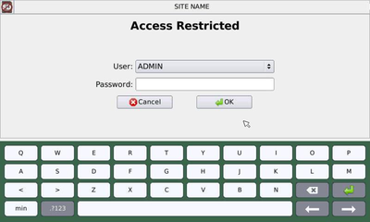
- Products
  - Sense cable
    - Performance
The sense cable shall perform the following functions continuously
                - Detection of the presence of liquid at any point along its length
                - Location of the leak to the nearest metre or on the cable
                - Detection of a cut or break at any point
                - Digital communication of the nature and location of the fault to the digital unit
    - Construction
The sense cable shall consist of a helically-winded central core (data bus), on which PEHD (Polyethylene high-density) conductor wires are spiralled. This shall ensure a prompt detection as well as a short drying time after the risk is eliminated.
The insulation and signal wires shall be made of flame-retardant polymer. The jacket of sense wires shall be made of conductive polymer on the ground wire. The active sense wire shall have a special dust-proof construction and shall not be affected if in contact with any metal parts like cable baskets, flooring or ground braids.
    - The sense cables shall be connected via male and female connectors. A microcontroller shall be embedded in the sense cable to ensure digital and independent leak detection and communication between each sense cable and the digital monitoring unit.
    - Each sense cable shall have its own identity or unique address. This shall be programmed directly by the installer or the user, using the touch screen on the front face of the monitoring unit.
    - The status of the sense cable shall be indicated by a LED embedded in the cable connector. Green blinking light indicates a normal status, red blinking light indicates a leak on the cable.
    - The sense cable shall be made of an abrasive-resistant material. The sense cable shall be made of light and flexible material in an easily identifiable colour.
    - Accessories shall be pre-connected. Belden 8723 jumper cable as well as end termination plug shall ensure the continuity of each circuit.
    - The sense cable shall be Underwriters Laboratories (UL) listed.
We recommend the FG-EC, FG-AC sense cables from TTK.

  - Digital monitoring unit
    - General
The digital monitoring unit shall be a microprocessor based complete leak locating system. It shall receive data processed and transmitted by each sense cable as well as raising the alarm. It shall be supplied from the same supplier as the sense cables.
    - Power
The digital monitoring unit shall be supplied by 100 VAC to 240 VAC, 50-60Hz, single phase. The total power consumption shall not exceed 25 VA.
    - Touch screen display
A (7”) touch screen display shall be assembled on the front of the digital monitoring unit. In the event of simultaneous leaks or multiple faults, the display shall show all alarms. English shall be the default language.
    - Menus shall have on the digital monitoring unit:-
      - “Setup”: the user shall be able to set acknowledge mode, user access, relay status, time zone, language, sound alarm, serial links and network functionalities. An admin password shall be required to access this menu.
      - “Event log”: to view alarm history recorded.
Up to five thousand (5000) events shall be stored in the event log on a FIFO basis.
      - “Cables”: the system shall be able to provide a general view of the installation on the screen. An interactive floor plan shall be available under this menu as an optional feature.
      - “Help”: a help section shall be available for troubleshooting.

Example:
    - Interface
There shall be configurable dry contacts available in the system to enable remote monitoring and control. The dry contacts shall indicate normal and alarm condition. The relay position shall be identified by a luminous indicator located on the motherboard of the digital unit. Any interruption in power shall be indicated by a specific dry contact.
RS-232, RS-422/485 serial ports with Modbus/Jbus communication protocol shall be available on the digital monitoring unit. An Ethernet port shall be available on the monitoring unit, for providing network functionalities.
    - Enclosure
The digital monitoring unit shall be enclosed in a dust-tight enclosure.
    - Norms and Standards
The monitoring unit shall have CE.

  - Jumper cable connection and auxiliary equipment
    - Where leak detection is required, a four-core jumper cable shall be used to connect sense cables in between zones, floors or rooms.
    - Warning labels shall be placed on the sense cable approximately every five (5) metres. Hold-down clips shall be used to fix the sense cables every one (1) metre.

- Installation
The system shall be installed by well trained staff, with the procedure recommended by the manufacturer.

- Manufacturer
The digital leak detection system shall be manufactured by:
TTK S.A.S.
19 rue du General Foy Tel: +33.1.56.76.90.10
75008 Paris Fax: +33.1.55.90.62.15
France Website: http://www.ttk.sg, http://www.ttkuk.com, http://www.ttkasia.com
Email: sales@ttk.sg, sales@ttkuk.com; sales@ttkasia.com

