liquids leak dectection system specification
- Overview
A liquids leak detection system is recommended for a continuous protection from the risk of water and other liquids leakage in the building.
This complete liquids leak detection system shall be based on a digital monitoring unit, addressable sense cables, jumper cables and all required auxiliary equipment. This system shall detect and locate multiple leaks simultaneously as well as cable break faults.
We recommend the FG-SYS digital unit from TTK.

- System performance
  - General
The liquids leak detection system shall identify any abnormal presence of liquid on any point of its connected sense cables, to the nearest metre. In the event of leakage, an audible alarm is triggered, the indicator light changes to red, the dry contact is activated and the display shows details of the fault, and its location to the nearest metre.
  - Sense cable length
The system shall be capable of monitoring up to 1800 meter of cable from a single monitoring unit. This length shall not include the jumper cable.
  - Multiple leaks
The system shall be capable of managing information of all leaks related to the number of sense cables installed. (E.g. 120 sense cables installed=120 possible detected and displayed leaks).
  - Cable break fault
Besides leak, the system shall be capable to detect circuit interruption (cable break) on any of its connected sense cables. In the event of a “cable break”, an audible alarm is triggered, the indicator light changes to red, the dry contact is activated and the display shows “cable break” and its location.
  - Liquid types
The system shall be capable of detecting conductive and non-conductive liquids, as water, bases, acid, hydrocarbon and solvents using different types of sense cables. These sense cables shall be able to be connected simultaneously on one digital monitoring unit.
  - Security
To enter the configuration menu, the system shall require a password.

- Products
  - Sense cable
    - Performance
The sense cable shall continuously perform three functions: to detect the presence of liquid at any point along its length, to detect a cut or break at any point along its length and to communicate digitally the nature and location of the fault to the nearest metre.
    - Construction
The sense cable shall consist of a helically-winded central core (data bus), on which PEHD (Polyethylene high-density) conductor wires are spiraled. This shall ensure a prompt detection as well as a short drying time after the risk is eliminated.
The insulation and signal wires shall be of flame-retardant polymer. The jacket of sense wires shall be of conductive polymer on the ground wire. The active sense wire shall have special dust-proof construction and shall not be affected if in contact with any solid particles.
    - The sense cables shall be connected via the male and female connectors. A microcontroller shall be embedded in the sense cable to ensure digital and independent communication between each sense cable and the digital monitoring unit.
    - Each sense cable or associated sense cables shall have its own identity or unique address; this shall be programmed directly by the installer or the user, using the keyboard on the front face of the monitoring unit.
    - The status of the sense cable shall be indicated by a LED embedded. Green blinking light indicates a normal status; red blinking light indicates a leak on this cable.
    - The sense cable shall be made of an abrasive-resistant material, tested in hostile environments. The sense cable shall be made of light and flexible material in an easily identifiable color.
    - There shall be pre-finished connection accessories. Belden 8723 jumper cable as well as end termination plug shall bring the continuity to each circuit.
    - The sense cable shall be Underwriters Laboratories (UL) listed.
We recommend the FG-EC, FG-AC sense cables from TTK.

  - Digital monitoring unit
    - General
The digital monitoring unit shall be a microprocessor based complete leak locating system. It shall receive data processed and transmitted by the sense cables as well as raising the alarm.
    - Power
The digital monitoring unit shall be supplied by 120 VAC - 240 VAC, 50/60Hz, single phase. The total power consumption shall not exceed 16 VA.
    - Buttons shall have on the front of digital monitoring unit:-
      - “Test”: to check system operations
The monitoring unit shall start a self-test automatically once powered on. The name and total quantity of cables on every output shall be shown on the LCD display on the front of the digital monitoring unit.
      - “Esc”: to acknowledge and silence the alarm
      - “Menu”: to configure the digital monitoring unit
      - “History”: to record alarm history
Event log of (30) events deep shall provide storage on a FIFO basis. When the memory is full, the latest record shall be stored and the earliest record shall then drop out automatically.
    - Communication
There shall be configurable dry contacts available in the system to enable remote monitoring and control. The dry contacts shall indicate normal and alarm condition. They shall be embedded with possible extension if required. Any interruption in power shall be acknowledged by the General dry contact.
The digital monitoring unit shall be compatible with existing operating systems. RS-232, RS-485 serial ports with Modbus/Jbus communication protocol shall be available on the digital monitoring unit, so as to interface with executive and streamline printing.
    - Enclosure
The digital monitoring unit shall be enclosed in NEMA12 enclosure.
    - LCD display
A four (4) lines by twenty (20) characters backlit LCD shall be located on the front of the digital monitoring unit. In the event of simultaneous leaks or multiple faults, the display shall show all alarms one after the other. English language shall be the language by default.
    - Indicator light
An indicator light placed at the front of the digital monitoring unit shall indicate both power and alarm status.
    - Qualifications
The monitoring unit shall be UL listed, CE and TUV compliant.

  - Jumper cable connection and auxiliary equipment
    - Where leak detection is required, a four core jumper cable shall be used to connect sense cables in between zones, floors or rooms.
    - Warning labels shall be placed on the sense cable approximately every five (5) meters. Hold-down clips shall be used to fix the sense cables every one (1) meter.
    - Floor plan
Schematic drawings shall be representing the layout of the leak detection system installed. It shall indicate the location of sense cables, jumper cables and all auxiliary equipments, as per the example below.
It shall be provided by the contractor installing the water leak detection system. The floor plan is essential for a good management of the leak detection system since it makes it possible to locate quickly the fault, as indicated by the digital monitoring unit.

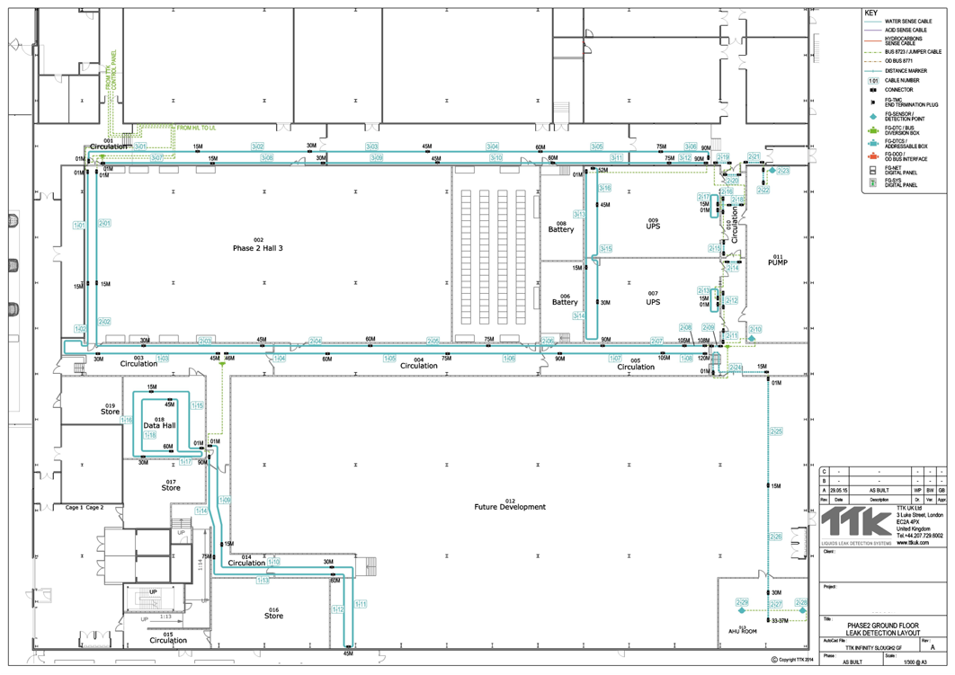

- Installation
The system shall be installed by well trained staff, with the procedure recommended by the manufacturer.

- Manufacturer
The digital leak detection system shall be manufactured by:
TTK S.A.S.
19 rue du General Foy Tel: +33.1.56.76.90.10
75008 Paris Fax: +33.1.55.90.62.15
France Website: http://www.ttkuk.com
Email: sales@ttkuk.com

